CYPRUS INTERNATIONAL UNIVERSITY
Faculty of Engineering
CMPE344 - Database Management Systems and Programming II
Instructor: Prof. Dr. Melike Sah Direkoğlu

PROJECT REPORT
Sports Tournament Database Management System

Student No | Full Name
22000972 | Abdullah Bin Shamla
21812355 | Abdulaziz Alamodi
22215256 | Ibrahim Almualm
22207460 | Mohammed Salmen

Report Submission Date: May 17, 2026
Presentation Week: May 18-22, 2026

1. Introduction

1.1 System Overview
The Sports Tournament Database Management System is a web-based application designed to manage all aspects of sports tournaments including team registration, player management, match scheduling, score tracking, and statistical reporting. The system provides a centralized platform for administrators, employees, team managers, players, and viewers to interact with tournament data in real time.

The system is built using Python (Streamlit framework) as the frontend GUI and PostgreSQL hosted on Supabase as the cloud database backend. The application is deployed online and accessible from any browser.

1.2 System Assumptions
- Each player belongs to exactly one team per tournament.
- A match must involve exactly two different teams from the same tournament.
- Match statistics are recorded per player per match.
- User authentication is role-based: admin, employee, team_manager, player, viewer.
- The system supports multiple simultaneous tournaments of different sport types.

1.3 Group Members
Student No | Full Name
22000972 | Abdullah Bin Shamla
21812355 | Abdulaziz Alamodi
22215256 | Ibrahim Almualm
22207460 | Mohammed Salmen

2. Database Design

2.1 ER Diagram
The Entity-Relationship diagram below illustrates the structure of the Sports Tournament database with all 7 tables and their relationships.
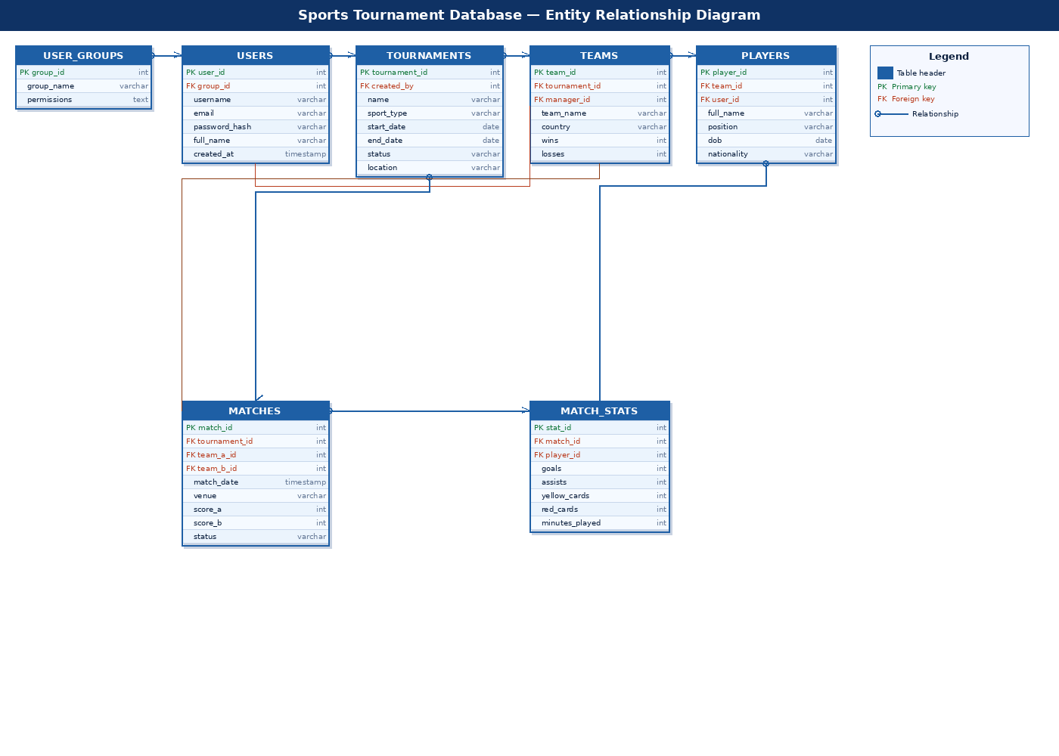

2.2 Database Tables Description
The database consists of 7 tables as described below:

Table | Description | Primary Key
user_groups | Defines user roles: admin, employee, team_manager, player, viewer | group_id
users | Stores login credentials and profile for all system users | user_id
tournaments | Stores tournament information including sport type and schedule | tournament_id
teams | Stores team details linked to a tournament and manager | team_id
players | Stores player profiles linked to a team | player_id
matches | Stores match schedule, scores and status | match_id
match_stats | Stores per-player statistics for each match | stat_id

2.3 Data Definition Language (DDL)
The following SQL statements create all database tables with primary keys, foreign keys, constraints, and default values.

Table: user_groups
CREATE TABLE user_groups (
group_id SERIAL PRIMARY KEY,
group_name VARCHAR(50) NOT NULL UNIQUE,
permissions TEXT NOT NULL
);

Table: users
CREATE TABLE users (
user_id SERIAL PRIMARY KEY,
group_id INT NOT NULL REFERENCES user_groups(group_id),
username VARCHAR(50) NOT NULL UNIQUE,
email VARCHAR(100) NOT NULL UNIQUE,
password_hash VARCHAR(255) NOT NULL,
full_name VARCHAR(100) NOT NULL,
created_at TIMESTAMP DEFAULT NOW()
);

Table: tournaments
CREATE TABLE tournaments (
tournament_id SERIAL PRIMARY KEY,
created_by INT NOT NULL REFERENCES users(user_id),
name VARCHAR(100) NOT NULL,
sport_type VARCHAR(50) NOT NULL,
start_date DATE NOT NULL,
end_date DATE NOT NULL,
status VARCHAR(20) DEFAULT 'upcoming'
CHECK (status IN ('upcoming','ongoing','completed')),
location VARCHAR(100)
);

Table: teams
CREATE TABLE teams (
team_id SERIAL PRIMARY KEY,
tournament_id INT NOT NULL REFERENCES tournaments(tournament_id),
manager_id INT NOT NULL REFERENCES users(user_id),
team_name VARCHAR(100) NOT NULL,
country VARCHAR(60),
wins INT DEFAULT 0 CHECK (wins >= 0),
losses INT DEFAULT 0 CHECK (losses >= 0)
);

Table: players
CREATE TABLE players (
player_id SERIAL PRIMARY KEY,
team_id INT NOT NULL REFERENCES teams(team_id),
user_id INT REFERENCES users(user_id),
full_name VARCHAR(100) NOT NULL,
position VARCHAR(50),
dob DATE,
nationality VARCHAR(60)
);

Table: matches
CREATE TABLE matches (
match_id SERIAL PRIMARY KEY,
tournament_id INT NOT NULL REFERENCES tournaments(tournament_id),
team_a_id INT NOT NULL REFERENCES teams(team_id),
team_b_id INT NOT NULL REFERENCES teams(team_id),
match_date TIMESTAMP NOT NULL,
venue VARCHAR(100),
score_a INT DEFAULT 0 CHECK (score_a >= 0),
score_b INT DEFAULT 0 CHECK (score_b >= 0),
status VARCHAR(20) DEFAULT 'scheduled'
CHECK (status IN ('scheduled','live','completed')),
CHECK (team_a_id <> team_b_id)
);

Table: match_stats
CREATE TABLE match_stats (
stat_id SERIAL PRIMARY KEY,
match_id INT NOT NULL REFERENCES matches(match_id),
player_id INT NOT NULL REFERENCES players(player_id),
goals INT DEFAULT 0 CHECK (goals >= 0),
assists INT DEFAULT 0 CHECK (assists >= 0),
yellow_cards INT DEFAULT 0 CHECK (yellow_cards >= 0),
red_cards INT DEFAULT 0 CHECK (red_cards >= 0),
minutes_played INT DEFAULT 0 CHECK (minutes_played >= 0),
UNIQUE (match_id, player_id)
);

2.4 Data Manipulation Language (DML)
Sample INSERT statements were used to populate the database with realistic sports data including 3 tournaments, 6 teams, 12 players, 6 matches, and 15 match statistics records.

Sample INSERT — user_groups
INSERT INTO user_groups (group_name, permissions) VALUES
('admin', 'full_access'),
('employee', 'manage_teams,manage_matches,manage_players'),
('team_manager', 'manage_own_team,view_matches'),
('player', 'view_own_stats,view_matches'),
('viewer', 'view_only');

Sample INSERT — users
INSERT INTO users (group_id, username, email, password_hash, full_name) VALUES
(1, 'admin1', 'admin@tournament.com', '$2b$12$hash...', 'Ahmad Al-Admin'),
(2, 'emp_sara', 'sara@tournament.com', '$2b$12$hash...', 'Sara Johnson'),
(3, 'mgr_brazil','brazil_mgr@teams.com', '$2b$12$hash...', 'Carlos Silva');

3. SQL Queries
The following 7 SQL queries demonstrate various database operations including joins, subqueries, aggregation functions, GROUP BY, ORDER BY, and HAVING clauses.

Query 1: Top Scorers per Tournament
Uses 4-table JOIN with GROUP BY and aggregate functions SUM and ORDER BY.
SELECT t.name AS tournament, p.full_name AS player,
tm.team_name AS team, SUM(ms.goals) AS total_goals,
SUM(ms.assists) AS total_assists
FROM match_stats ms
JOIN players p ON ms.player_id = p.player_id
JOIN teams tm ON p.team_id = tm.team_id
JOIN matches m ON ms.match_id = m.match_id
JOIN tournaments t ON m.tournament_id = t.tournament_id
GROUP BY t.name, p.full_name, tm.team_name
ORDER BY total_goals DESC;

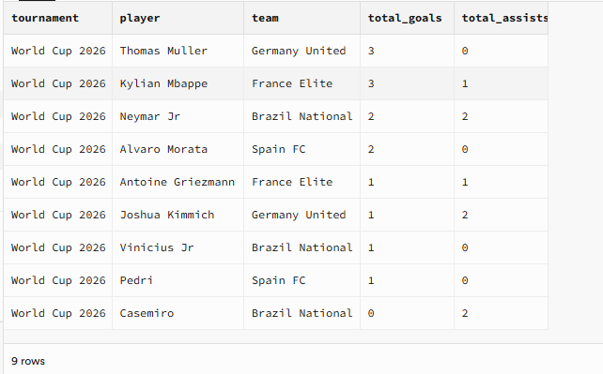

Query 2: Team Standings with Points
Uses JOIN and subquery to calculate draws. Points calculated as 3 per win.
SELECT tm.team_name, t.name AS tournament, tm.wins, tm.losses,
(SELECT COUNT(*) FROM matches m
WHERE (m.team_a_id=tm.team_id OR m.team_b_id=tm.team_id)
AND m.score_a=m.score_b AND m.status='completed') AS draws,
(tm.wins * 3) AS points
FROM teams tm
JOIN tournaments t ON tm.tournament_id = t.tournament_id
ORDER BY points DESC;

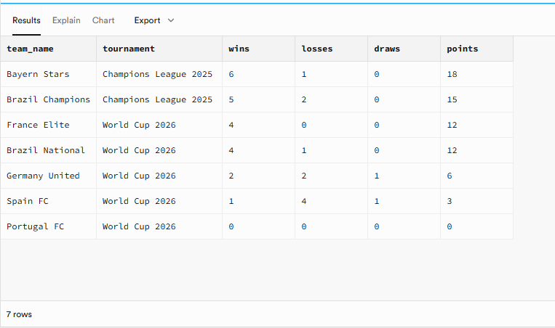

Query 3: Average Goals per Match per Tournament
Uses AVG, COUNT, SUM aggregate functions with GROUP BY and WHERE filter.
SELECT t.name AS tournament, COUNT(m.match_id) AS total_matches,
SUM(m.score_a + m.score_b) AS total_goals,
ROUND(AVG(m.score_a + m.score_b)::numeric, 2) AS avg_goals_per_match
FROM matches m
JOIN tournaments t ON m.tournament_id = t.tournament_id
WHERE m.status = 'completed'
GROUP BY t.name ORDER BY avg_goals_per_match DESC;

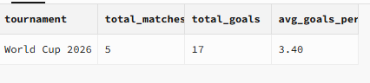

Query 4: Disciplinary Report — Players with Cards
Uses correlated subqueries to calculate total yellow and red cards per player.
SELECT p.full_name, tm.team_name, t.name AS tournament,
(SELECT SUM(ms2.yellow_cards) FROM match_stats ms2
WHERE ms2.player_id = p.player_id) AS total_yellows,
(SELECT SUM(ms2.red_cards) FROM match_stats ms2
WHERE ms2.player_id = p.player_id) AS total_reds
FROM players p
JOIN teams tm ON p.team_id = tm.team_id
JOIN tournaments t ON tm.tournament_id = t.tournament_id
WHERE (SELECT SUM(ms3.yellow_cards + ms3.red_cards)
FROM match_stats ms3 WHERE ms3.player_id = p.player_id) > 0
ORDER BY total_yellows DESC;

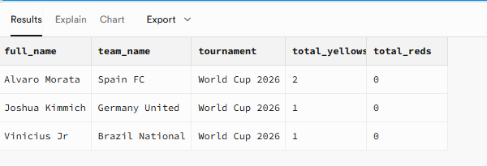

Query 5: Full Match Results with Team Names
Uses self-JOIN on teams table to display home and away team names side by side.
SELECT t.name AS tournament, ta.team_name AS home_team,
m.score_a AS home_score, m.score_b AS away_score,
tb.team_name AS away_team, m.match_date, m.venue, m.status
FROM matches m
JOIN tournaments t ON m.tournament_id = t.tournament_id
JOIN teams ta ON m.team_a_id = ta.team_id
JOIN teams tb ON m.team_b_id = tb.team_id
ORDER BY m.match_date;
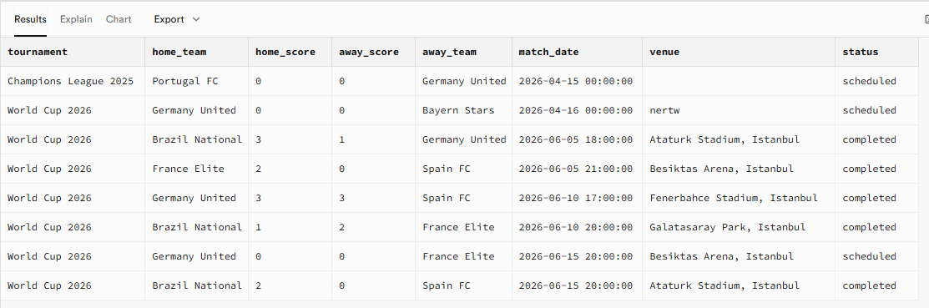

Query 6: Player Workload — Minutes and Goals
Uses COUNT, SUM aggregate functions with HAVING clause to filter active players.
SELECT p.full_name, p.position, tm.team_name,
COUNT(ms.match_id) AS matches_played,
SUM(ms.minutes_played) AS total_minutes,
SUM(ms.goals) AS goals, SUM(ms.assists) AS assists
FROM match_stats ms
JOIN players p ON ms.player_id = p.player_id
JOIN teams tm ON p.team_id = tm.team_id
GROUP BY p.full_name, p.position, tm.team_name
HAVING SUM(ms.minutes_played) > 0
ORDER BY total_minutes DESC;

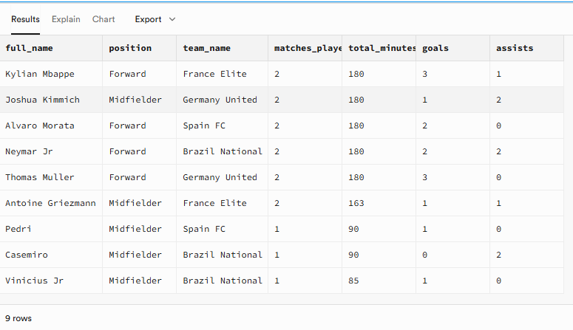

Query 7: User Group Statistics
Uses LEFT JOIN with COUNT and GROUP BY to show number of users per group.
SELECT ug.group_name, ug.permissions,
COUNT(u.user_id) AS total_users
FROM user_groups ug
LEFT JOIN users u ON ug.group_id = u.group_id
GROUP BY ug.group_name, ug.permissions
ORDER BY total_users DESC;

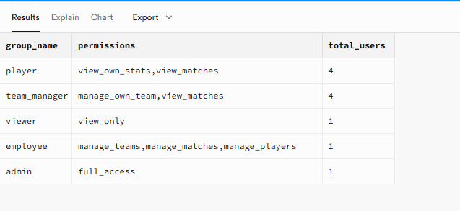

4. PL/SQL Blocks
The following 5 PL/SQL blocks demonstrate stored procedures, functions, and triggers implemented in PostgreSQL PL/pgSQL.

PL/SQL 1: Procedure — Register New Team
A stored procedure that validates tournament status before registering a new team. Raises an exception if the tournament does not exist or is not in upcoming status.
CREATE OR REPLACE PROCEDURE register_team(
p_tournament_id INT, p_manager_id INT,
p_team_name VARCHAR, p_country VARCHAR)
LANGUAGE plpgsql AS $$
BEGIN
IF NOT EXISTS (SELECT 1 FROM tournaments
WHERE tournament_id = p_tournament_id AND status = 'upcoming')
THEN
RAISE EXCEPTION 'Tournament % not found or not upcoming', p_tournament_id;
END IF;
INSERT INTO teams (tournament_id, manager_id, team_name, country)
VALUES (p_tournament_id, p_manager_id, p_team_name, p_country);
RAISE NOTICE 'Team registered successfully';
END; $$;
-- Test: CALL register_team(1, 3, 'Portugal FC', 'Portugal');
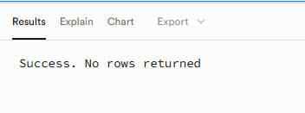

PL/SQL 2: Function — Get Total Goals for a Player
A function that accepts a player ID and returns the total number of goals scored by that player across all matches.
CREATE OR REPLACE FUNCTION get_player_goals(p_player_id INT)
RETURNS INT LANGUAGE plpgsql AS $$
DECLARE v_total INT;
BEGIN
SELECT COALESCE(SUM(goals), 0) INTO v_total
FROM match_stats WHERE player_id = p_player_id;
RETURN v_total;
END; $$;
-- Test: SELECT get_player_goals(1) AS neymar_total_goals;

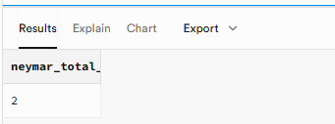

PL/SQL 3: Trigger — Auto-Update Team Wins and Losses
A trigger that automatically updates team win/loss records whenever a match status is changed to completed. If team A scores more, team A wins; otherwise team B wins.
CREATE OR REPLACE FUNCTION update_team_record()
RETURNS TRIGGER LANGUAGE plpgsql AS $$
BEGIN
IF NEW.status = 'completed' AND OLD.status <> 'completed' THEN
IF NEW.score_a > NEW.score_b THEN
UPDATE teams SET wins=wins+1 WHERE team_id=NEW.team_a_id;
UPDATE teams SET losses=losses+1 WHERE team_id=NEW.team_b_id;
ELSIF NEW.score_b > NEW.score_a THEN
UPDATE teams SET wins=wins+1 WHERE team_id=NEW.team_b_id;
UPDATE teams SET losses=losses+1 WHERE team_id=NEW.team_a_id;
END IF;
END IF;
RETURN NEW;
END; $$;
CREATE OR REPLACE TRIGGER trg_match_result
AFTER UPDATE ON matches FOR EACH ROW
EXECUTE FUNCTION update_team_record();


PL/SQL 4: Function — Tournament Summary Report
A table-returning function that provides a complete summary of a tournament including total teams, completed matches, total goals, and the name of the top scorer.
CREATE OR REPLACE FUNCTION tournament_summary(p_tournament_id INT)
RETURNS TABLE(total_teams INT, total_matches INT,
total_goals INT, top_scorer VARCHAR)
LANGUAGE plpgsql AS $$
BEGIN
RETURN QUERY
SELECT
(SELECT COUNT(*)::INT FROM teams WHERE tournament_id=p_tournament_id),
(SELECT COUNT(*)::INT FROM matches WHERE tournament_id=p_tournament_id
AND status='completed'),
(SELECT COALESCE(SUM(ms.goals),0)::INT FROM match_stats ms
JOIN matches m ON ms.match_id=m.match_id
WHERE m.tournament_id=p_tournament_id),
(SELECT p.full_name FROM match_stats ms
JOIN matches m ON ms.match_id=m.match_id
JOIN players p ON ms.player_id=p.player_id
WHERE m.tournament_id=p_tournament_id
GROUP BY p.full_name ORDER BY SUM(ms.goals) DESC LIMIT 1);
END; $$;
-- Test: SELECT * FROM tournament_summary(1);
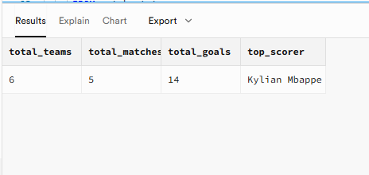

PL/SQL 5: Trigger — Prevent Duplicate Match Scheduling
A before-insert trigger that prevents scheduling the same two teams more than once on the same day within the same tournament. Raises an exception if a duplicate is detected.
CREATE OR REPLACE FUNCTION prevent_duplicate_match()
RETURNS TRIGGER LANGUAGE plpgsql AS $$
BEGIN
IF EXISTS (SELECT 1 FROM matches
WHERE tournament_id = NEW.tournament_id
AND DATE(match_date) = DATE(NEW.match_date)
AND match_id <> COALESCE(NEW.match_id, -1)
AND ((team_a_id=NEW.team_a_id AND team_b_id=NEW.team_b_id)
OR (team_a_id=NEW.team_b_id AND team_b_id=NEW.team_a_id))
) THEN
RAISE EXCEPTION 'These teams already play on this date';
END IF;
RETURN NEW;
END; $$;
CREATE OR REPLACE TRIGGER trg_no_duplicate_match
BEFORE INSERT OR UPDATE ON matches FOR EACH ROW
EXECUTE FUNCTION prevent_duplicate_match();

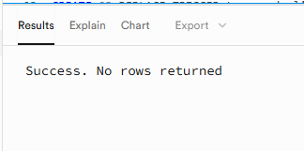

5. Software Implementation

5.1 Technology Stack
Component | Technology | Purpose
Frontend GUI | Python / Streamlit | Web-based user interface
Database | PostgreSQL on Supabase | Cloud database hosting
API | Supabase REST API | Database communication
HTTP Client | Python requests library | API calls from frontend
Deployment | Streamlit Cloud | Online hosting
Version Control | GitHub | Source code management

5.2 Database Connection Code
The application connects to Supabase using the REST API with the anon public key for authentication. All CRUD operations are performed through HTTP requests.
SUPABASE_URL = 'https://erasxbvtzurkcqxcmdxh.supabase.co'
SUPABASE_KEY = 'eyJhbGciOiJIUzI1NiIsInR5cCI6IkpXVCJ9...'

HEADERS = {
'apikey': SUPABASE_KEY,
'Authorization': f'Bearer {SUPABASE_KEY}',
'Content-Type': 'application/json',
'Prefer': 'return=representation'
}

def sb_get(table, select='*', filters=None):
url = f'{SUPABASE_URL}/rest/v1/{table}?select={select}'
if filters:
for k, v in filters.items():
url += f'&{k}=eq.{v}'
r = requests.get(url, headers=HEADERS)
return r.json() if r.status_code == 200 else []

5.3 Application Screens

Screen 1: Login
Users enter their username and password. The system queries the users table joined with user_groups to authenticate and determine the user role. Role-based access control is enforced throughout the application.

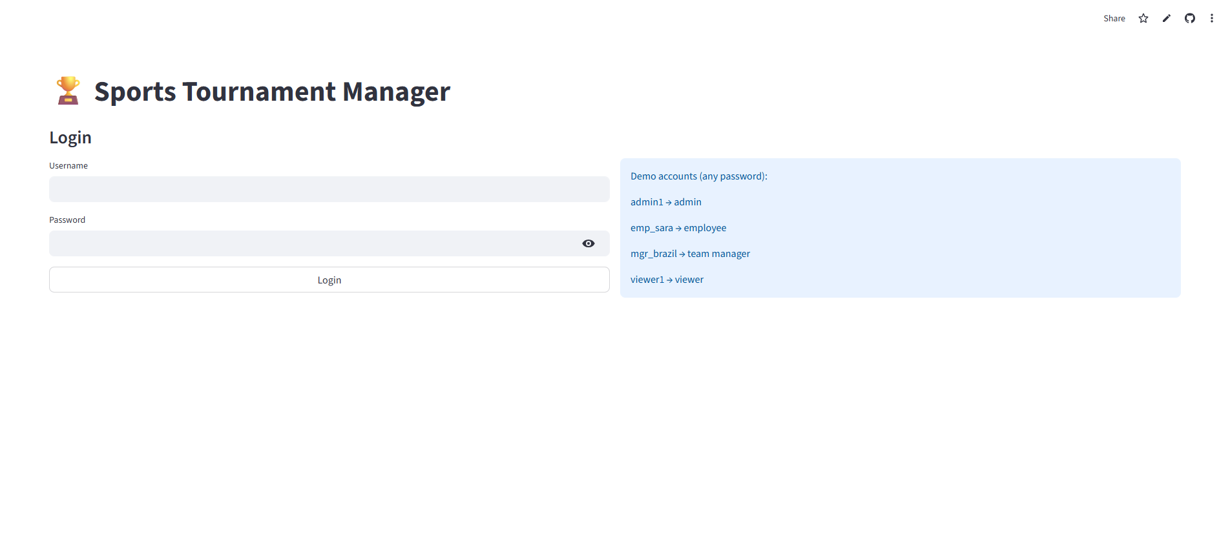

Screen 2: Dashboard
Displays key performance indicators (KPIs) including total tournaments, teams, players, and matches. Also shows the top scorers leaderboard, team standings with points, and upcoming scheduled matches.
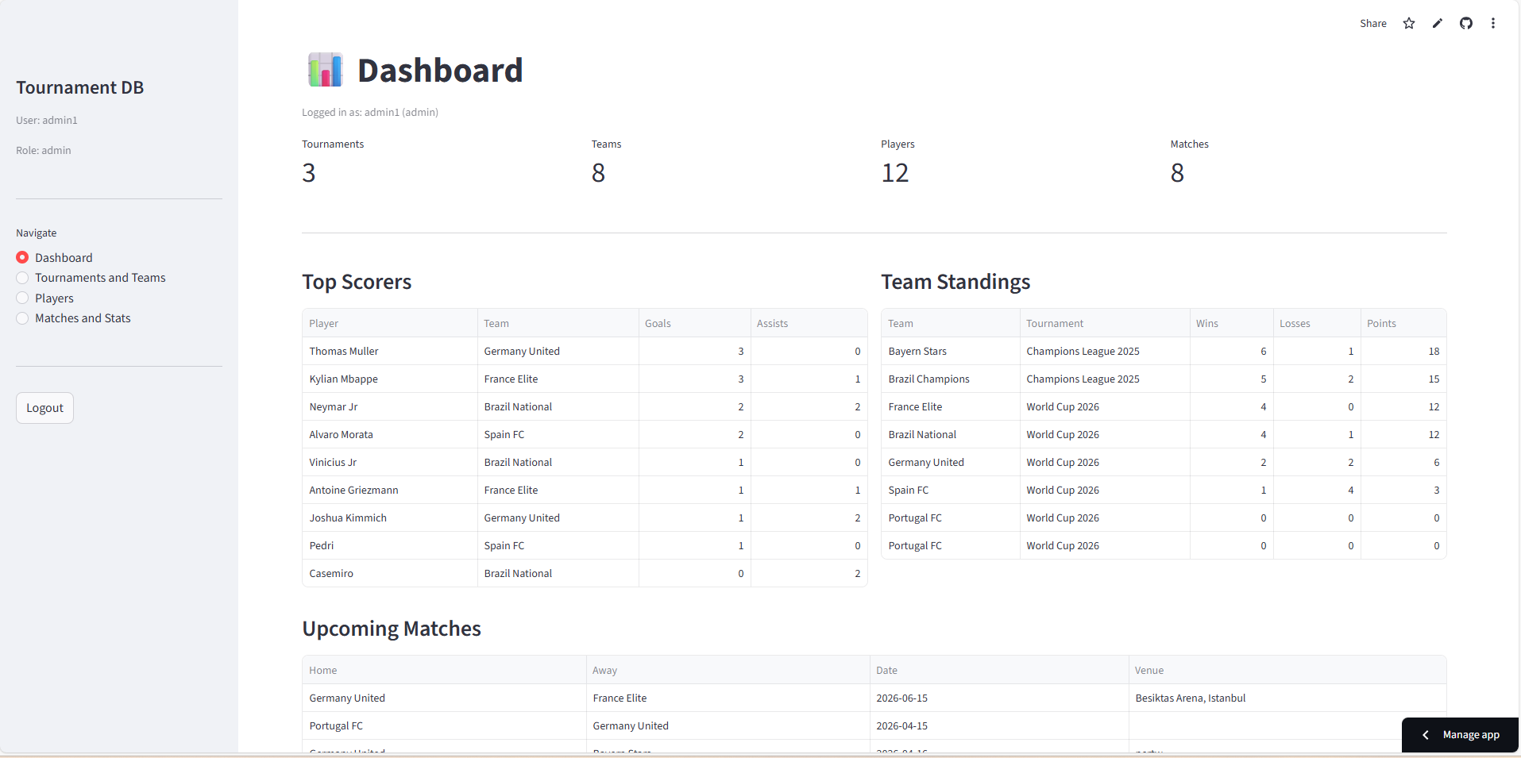

Screen 3: Tournaments and Teams
Administrators can view all tournaments, create new tournaments, and delete existing ones. Employees and admins can register new teams into upcoming tournaments. All users can view the team standings table.

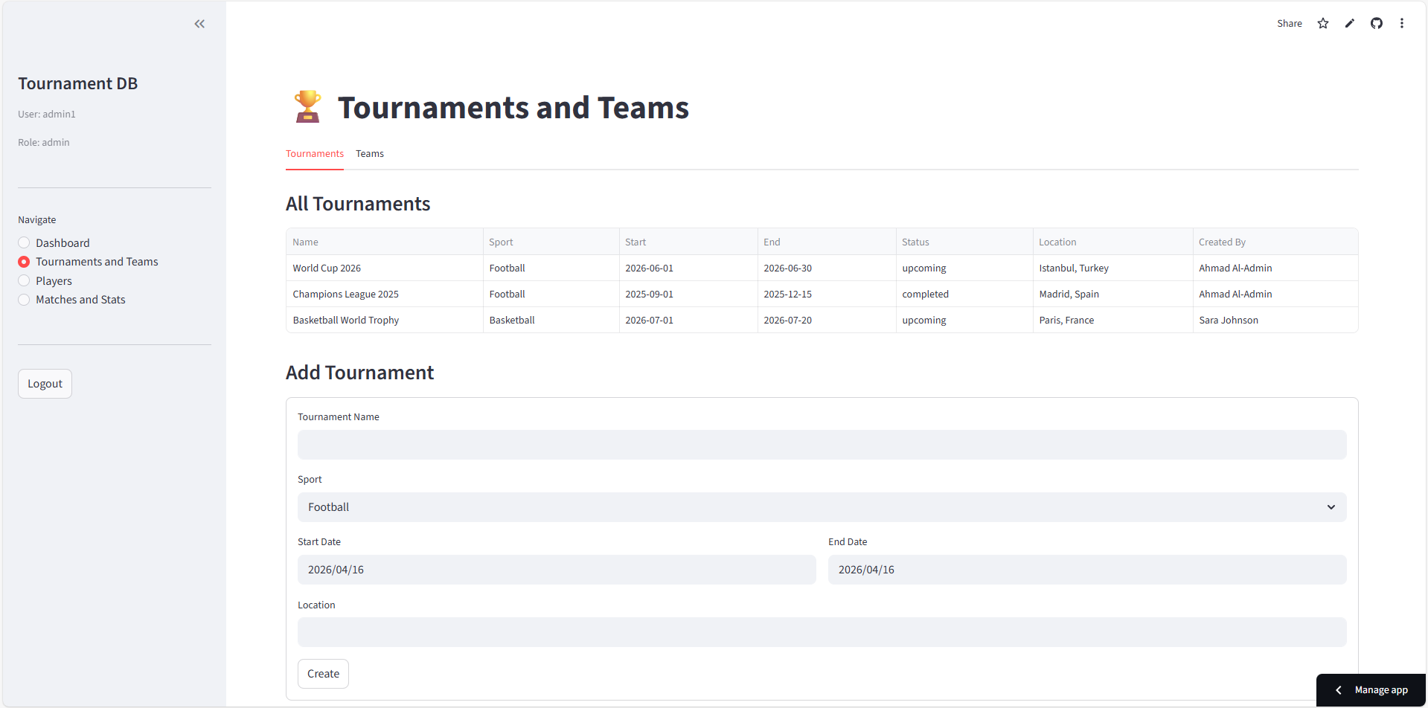

Screen 4: Players
Displays the full player roster with team and tournament information. Authorized users can add new players, update player positions and nationality, or delete players who have no match statistics.

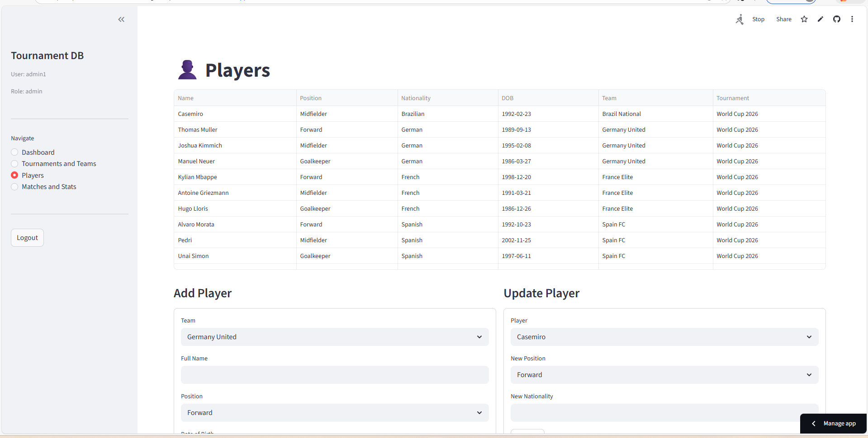

Screen 5: Matches and Statistics
Shows all match results with scores. Admins and employees can schedule new matches and update scores. The Player Stats tab aggregates total goals, assists, cards, and minutes played per player across all matches.
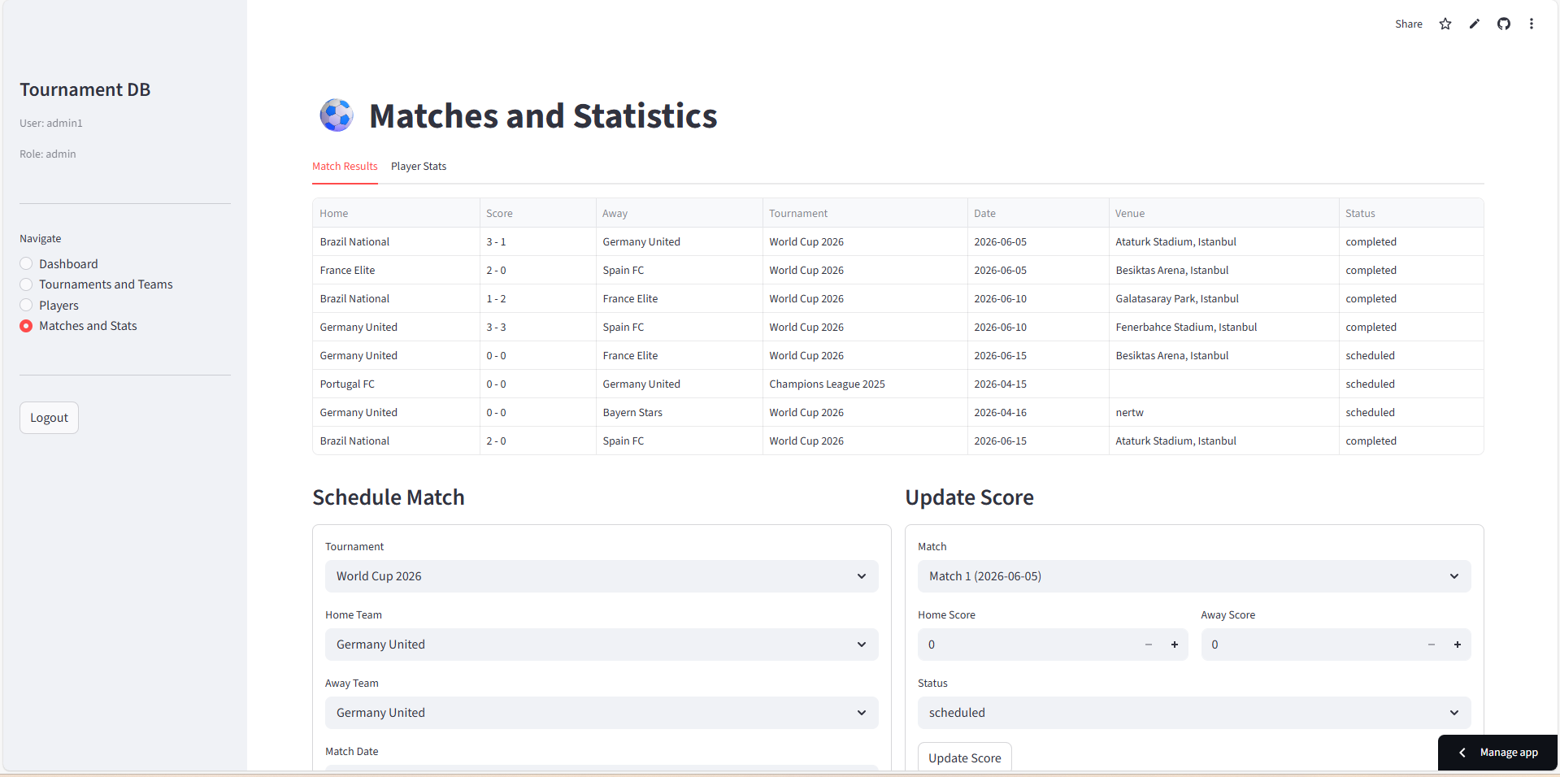

. GitHub Repository

6.1 Repository Information
Item | Details
Repository Name | sports-tournament-db
Visibility | Public
URL | https://github.com/21812355/sports-tournament-db.git
Branch | main

6.2 Repository Contents
File | Description
app.py | Main Streamlit application — all 5 screens
requirements.txt | Python dependencies: streamlit, requests, pandas
README.md | Project description and setup instructions

6.3 Deployment
The application is deployed on Streamlit Cloud and accessible at the following public URL:

https://sports-tournament-db-xudthg3vzmpwavxvx4rw7u.streamlit.app/

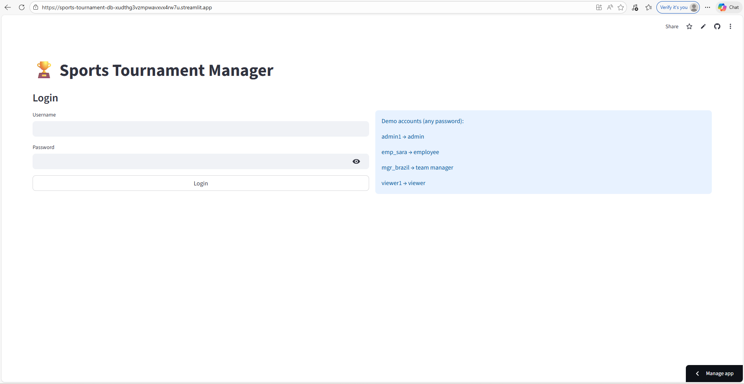

7. Conclusion
This project successfully demonstrates the full lifecycle of database design and implementation for a Sports Tournament Management System. The system covers all required components including:

- A normalized relational database with 7 tables, proper primary keys, foreign keys, and constraints.
- Role-based user authentication with 5 user groups.
- 7 SQL queries demonstrating joins, subqueries, aggregations, and grouping.
- 5 PL/SQL blocks including procedures, functions, and triggers.
- A fully functional web GUI with 5 screens deployed on Streamlit Cloud.
- Cloud database hosted on Supabase (PostgreSQL) accessible from anywhere.
- Source code published on a public GitHub repository.

The system is live and fully operational. All CRUD operations (Create, Read, Update, Delete) are functional for all 7 tables through the web interface.

